# **Olympics — 120 Years History Analysis**

**Introduction**

The Olympics, considered the world’s foremost sporting tournament, have a rich tradition spanning 120 years. From the original modern Olympics in Athens, Greece in 1896 to the most current one in Beijing, China in 2022, these events showcase a vast diversity of sports across summer and winter seasons.   
  
Here are some observations derived from a detailed analysis using Power BI:

**Data Collection**

This analysis used data from Maven Analytics. It consists of CSV files including information about athletes, events, countries, and Olympic data spanning 1896 to 2016.  
The data-set features 15 columns and 133,571 rows.

**Data Cleaning**

* Data cleansing was done in Power Query
* Columns not required for analysis were eliminated.
* Duplicate rows were found and deleted.
* Inconsistencies in country names were resolved by thoroughly examining and renaming the impacted rows.
* Furthermore, data transformations and aggregations were used to generate relevant metrics and variables for study.

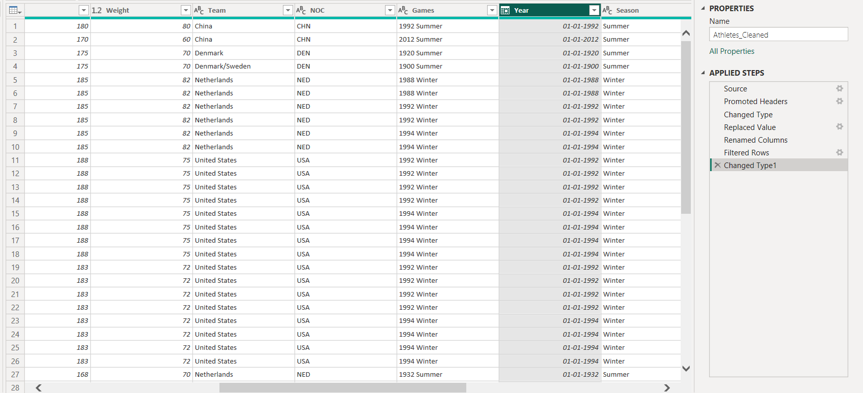

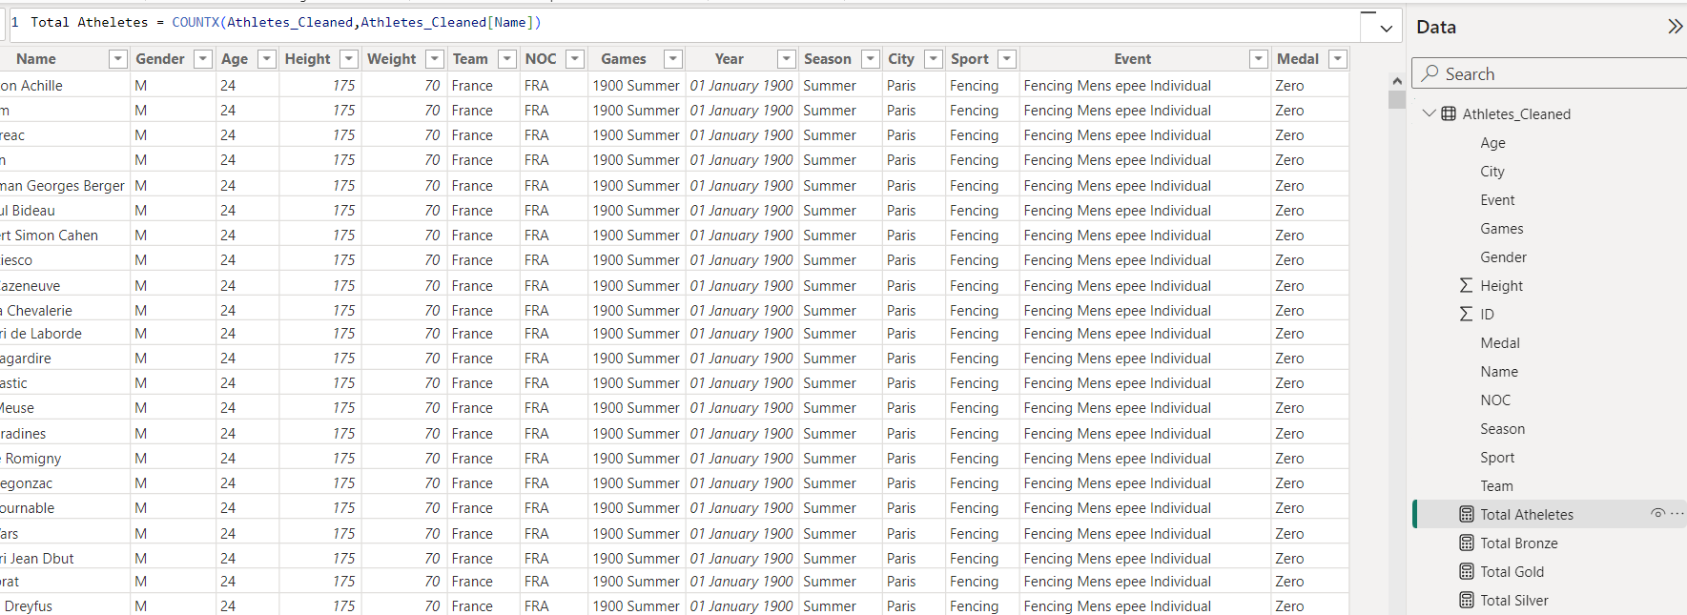

**Visualization & Analysis**

Power BI was utilized for data processing and visualization.

To display the data in an understandable and visually appealing way, visualizations such interactive dashboards, bar charts, line charts, tree map +and donut charts were developed.

The dashboard focuses on significant areas of Olympic history:

* Top Teams by Medals: A visual representation of the countries with the most medals across numerous Olympic editions.
* Medal Gender Distribution: An analysis of how medals are distributed among male and female athletes.
* Yearly Medal Distribution : Trends showing how medals are distributed by gender across Olympic years.
* Medal Distribution by Sport: A visual representation of medal distribution across multiple sports disciplines.
* Medal Distribution by Age: Analysis of medal winners by age group, with emphasis on age-related trends.

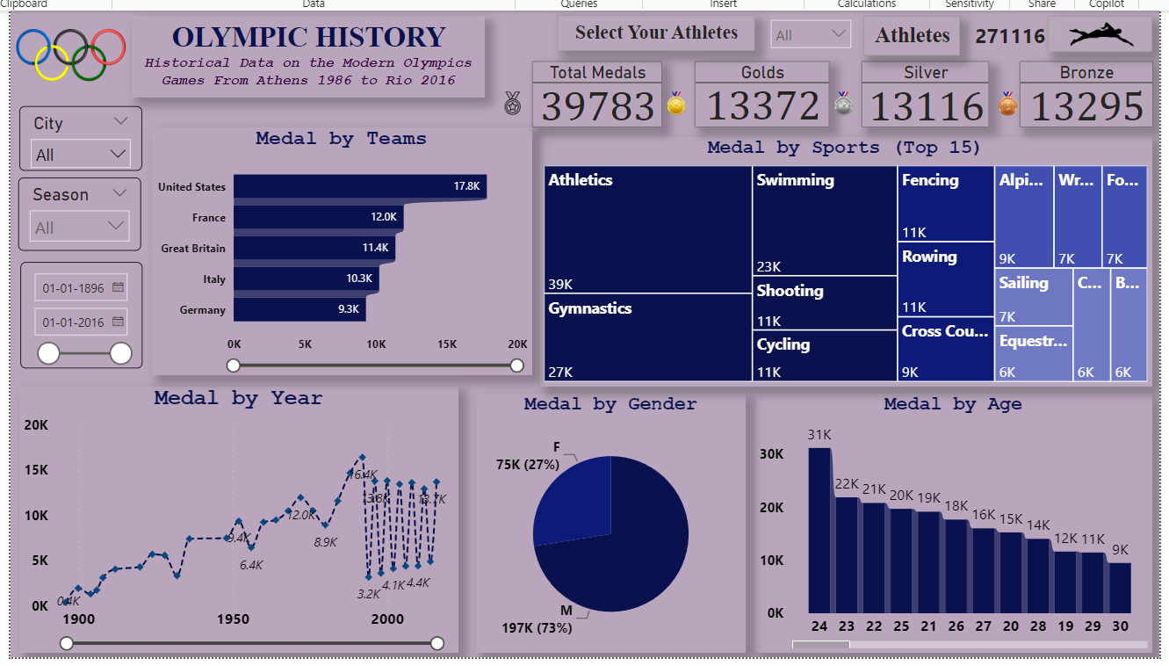

Naturally, further insights and visualizations can be extracted from the data. But I wrapped it up here for the purposes of this project.

**Conclusion**

The "120 Years of Olympic Games: A Comprehensive Review" project successfully used Power BI to convert raw Olympic Games data into a visually appealing and instructive dashboard. Using data cleansing, normalization, and visualization techniques, the project provided stakeholders with a comprehensive platform for exploring and understanding historical trends, top performers, and important factors influencing the Olympic Games over the past century.

**Report By** : Kunal Udapure